MyBokSmart (https://my.boksmart.com) www.BokSmart.com /BokSmart @BokSmart

Serious Injury Report Form
A serious and/or catastrophic injury is defined as any head, neck, spine, or brain injury that is life-threatening, or has the potential to be permanently debilitating and results in the emergency admission of a rugby player to a hospital or medical care centre.

WHAT TO DO!
- Record the details as accurately as possible regarding the player, the injury, and the relevant contact person from the school, club, or team in the spaces below
- Within 48 hours of the injury, either Fax or Email the completed report to the Serious Injury Case Manager, Mrs. Gail Baerecke – Cell: 0728903538, e-mail: manager@playersfund.org.za, fax: 021 659 5653
- The Serious Injury Case Manager will then inform SARU’s Senior Manager: Medical, SARU’s Senior Manager: Rugby Safety, and the relevant Provincial union
1. PLAYER (Print Clearly)
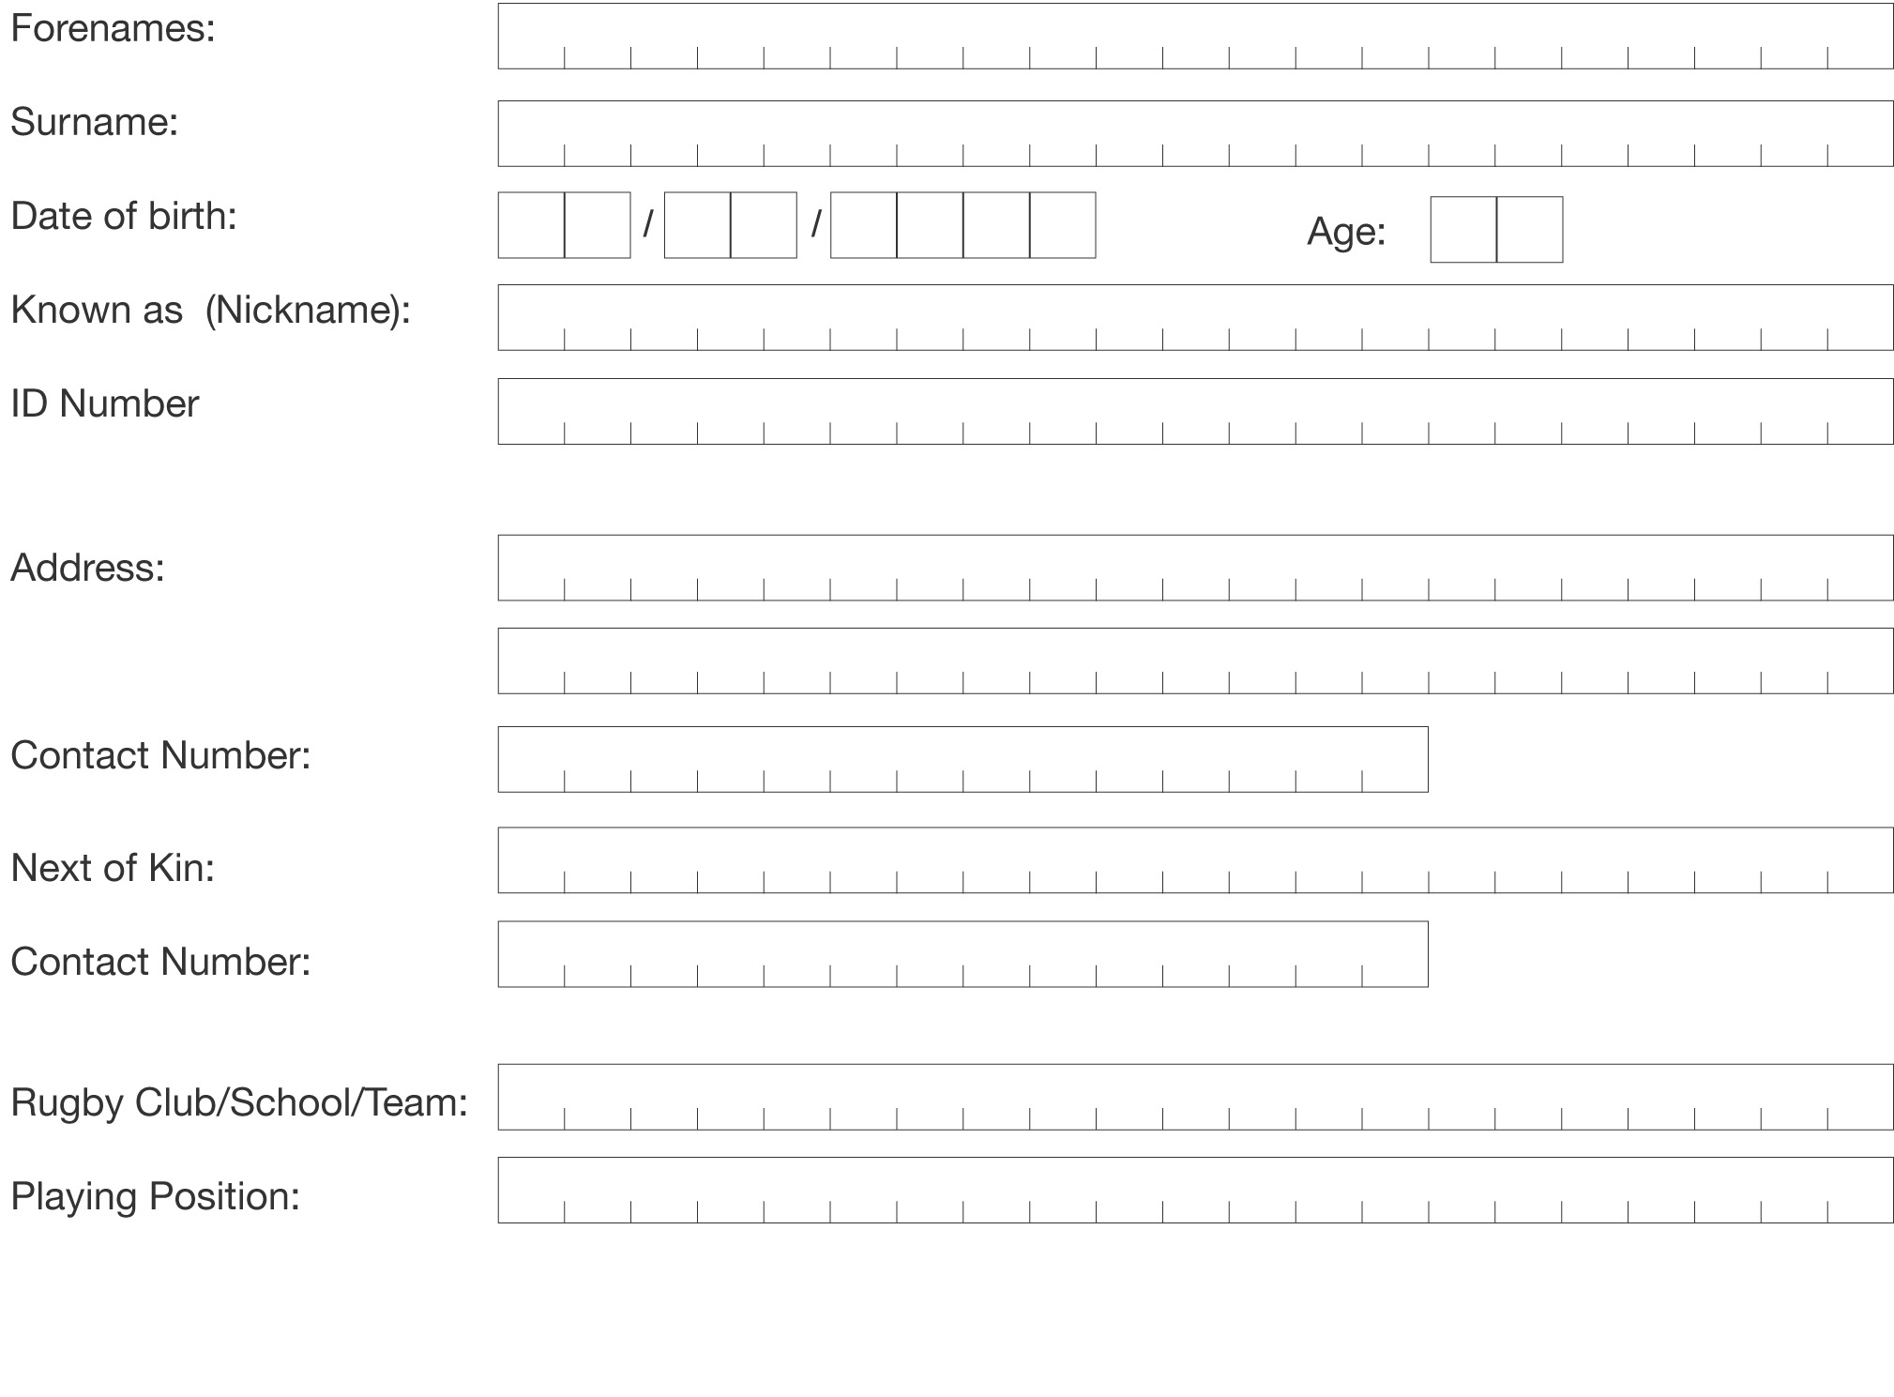

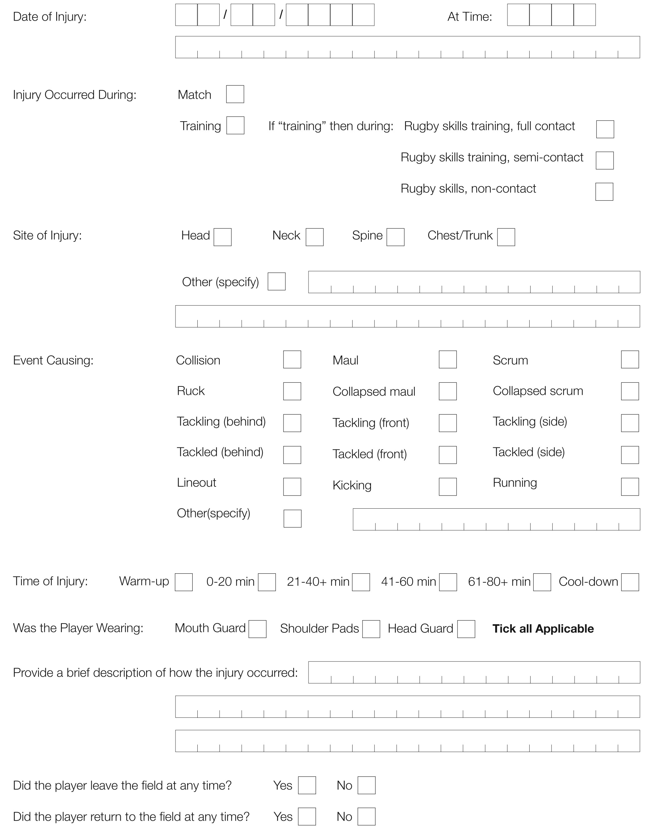
2. injury (Print Clearly)

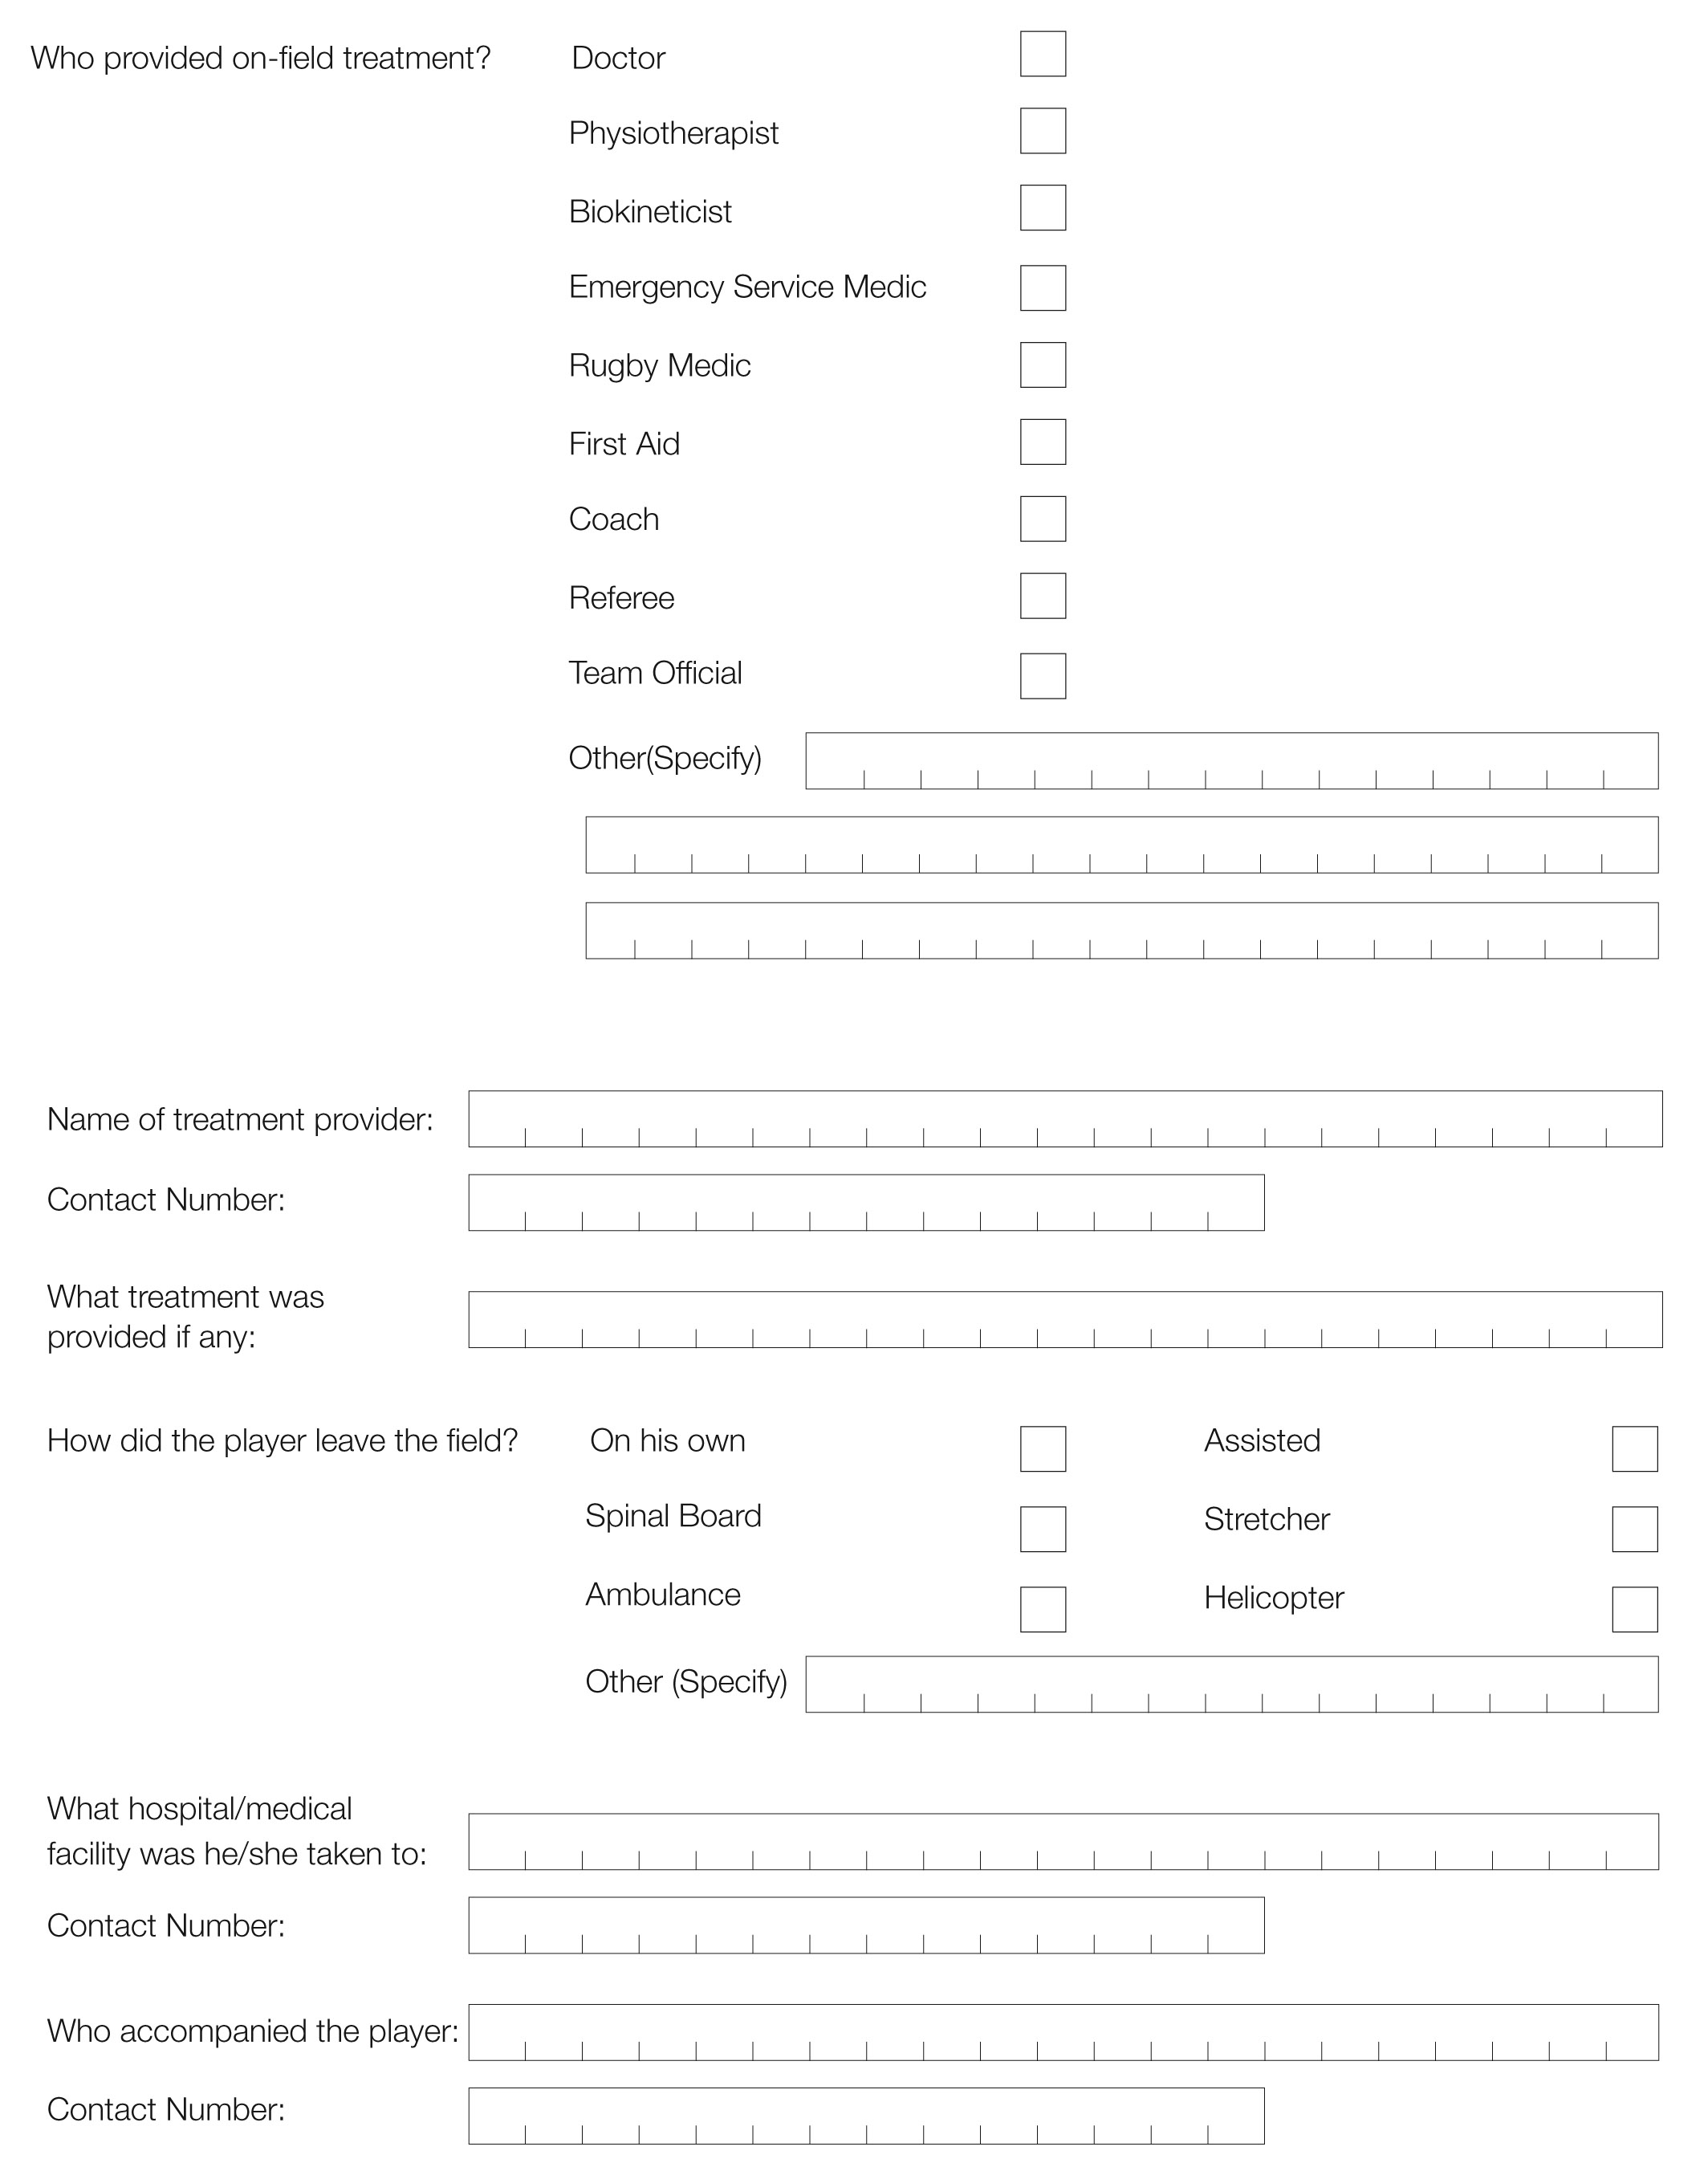
2. injury (Print Clearly) - Continued

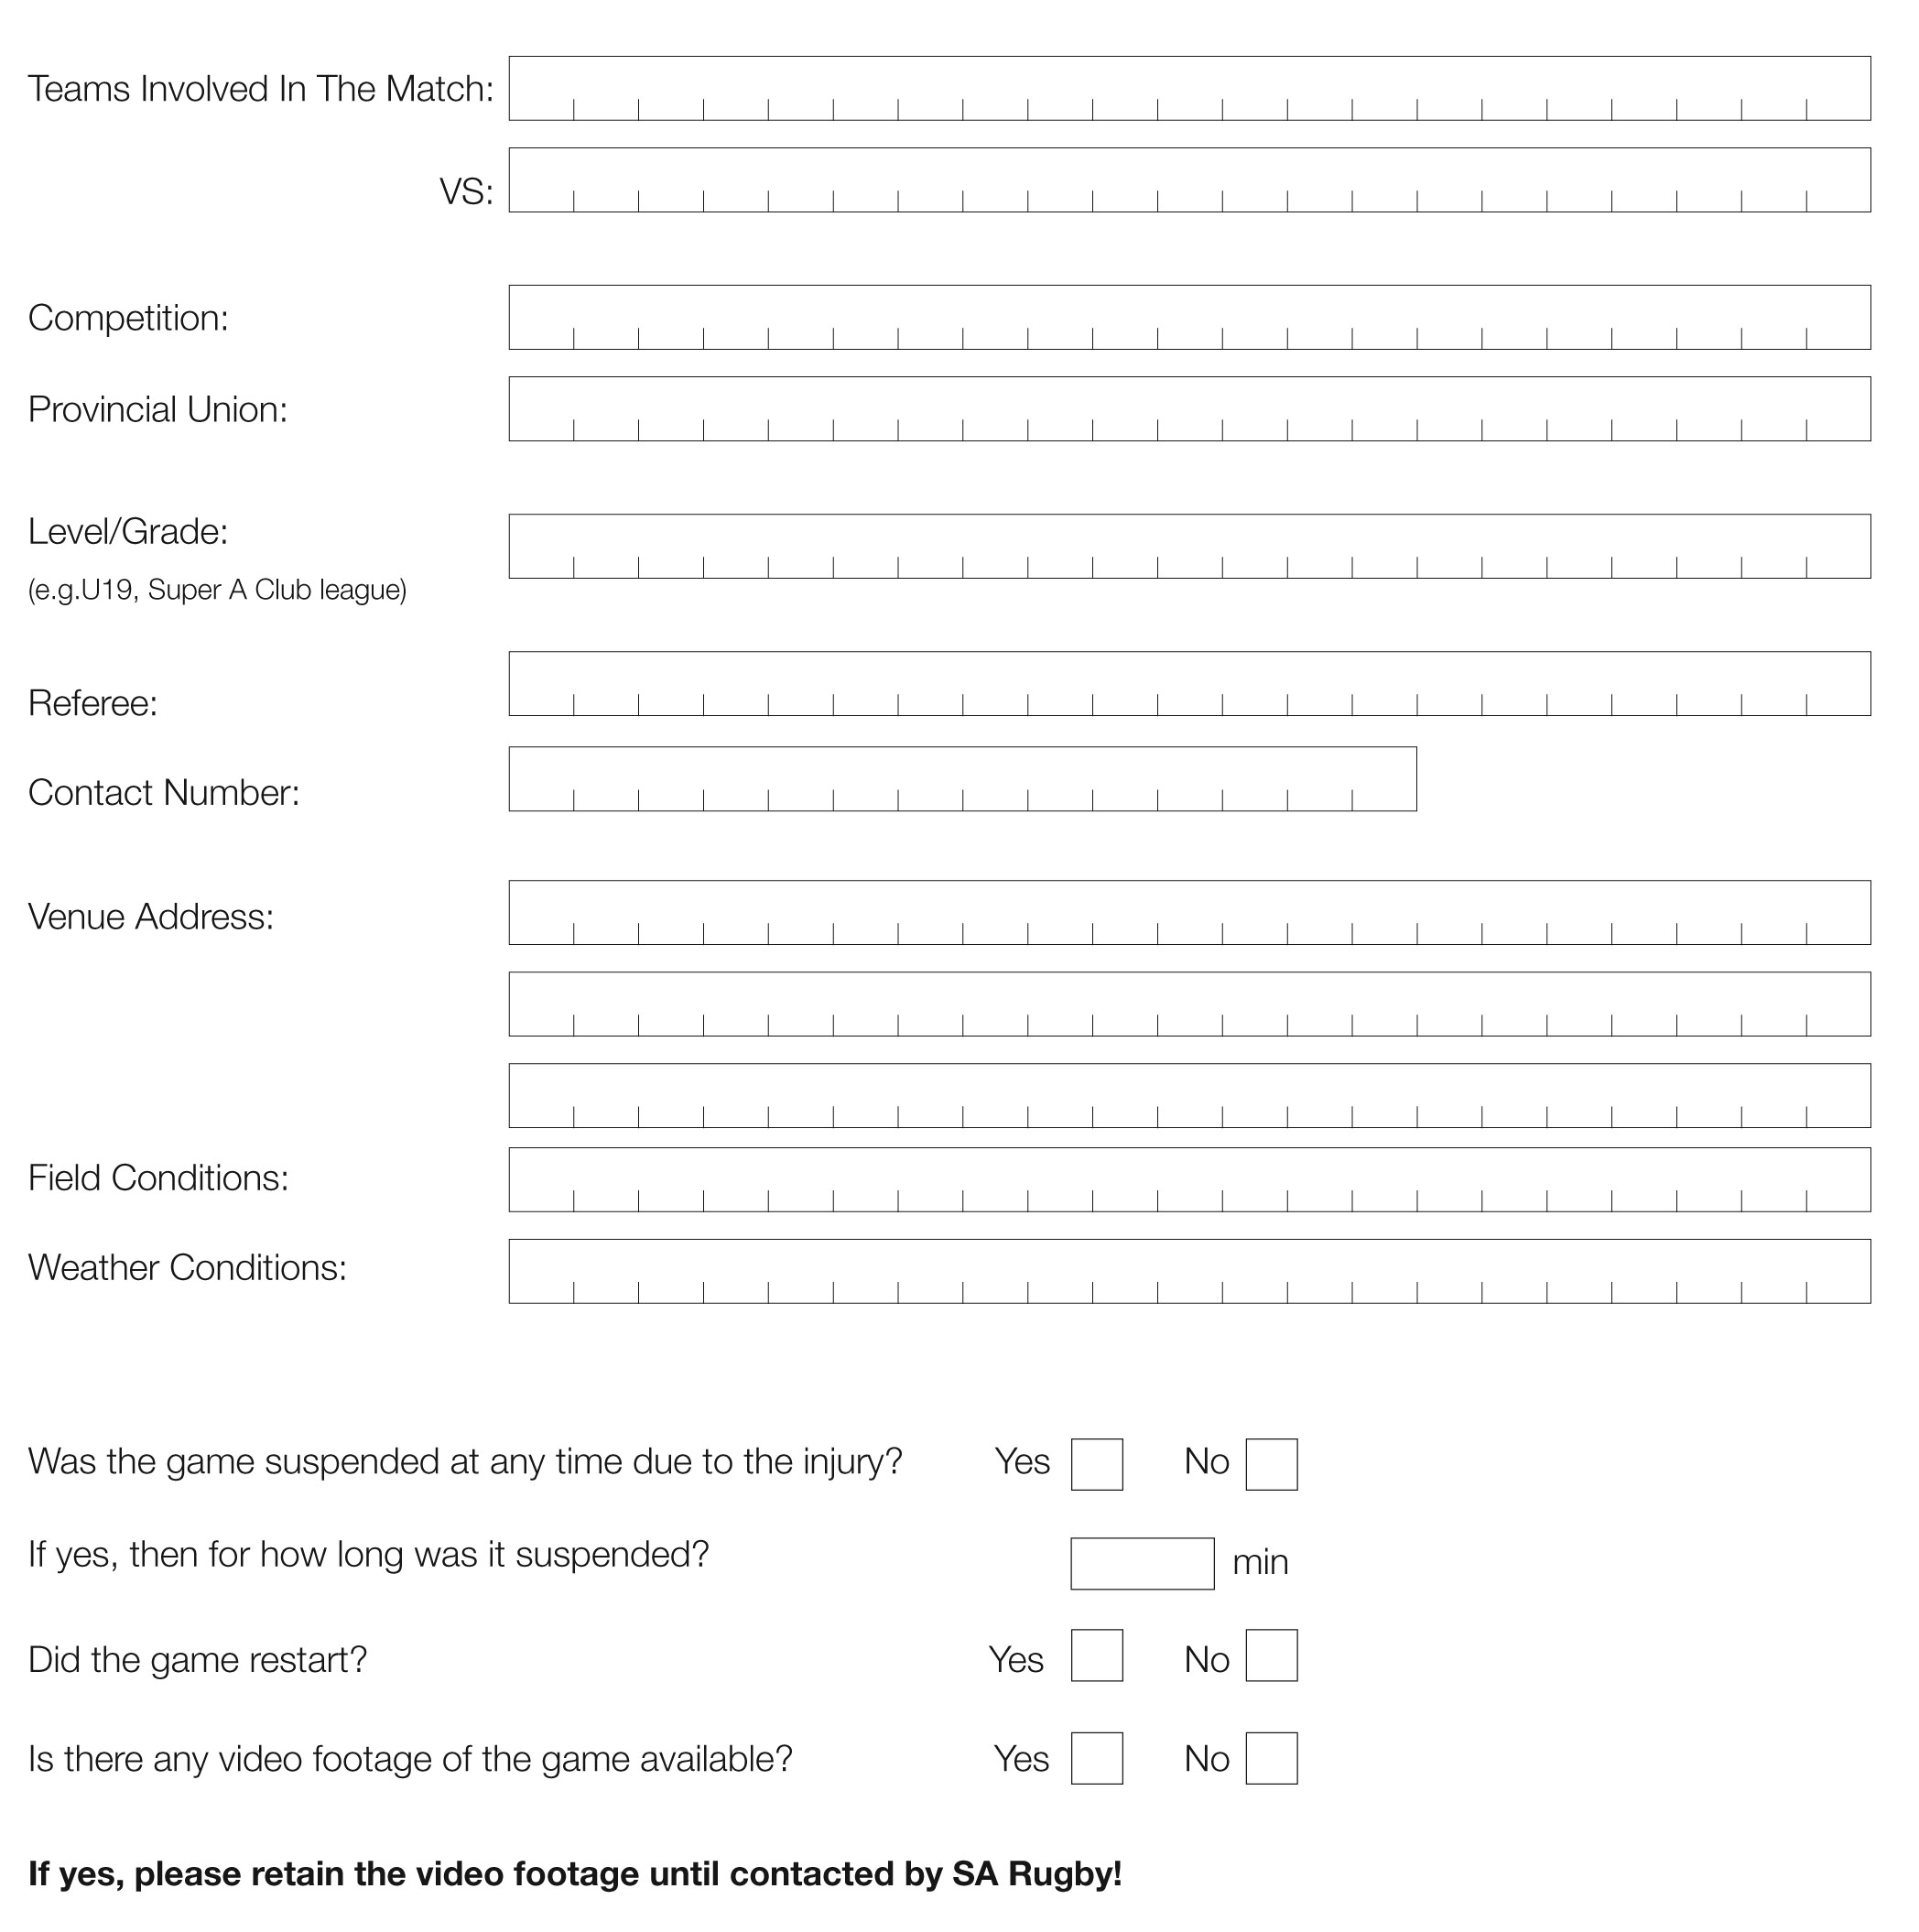
3. match (Print Clearly)

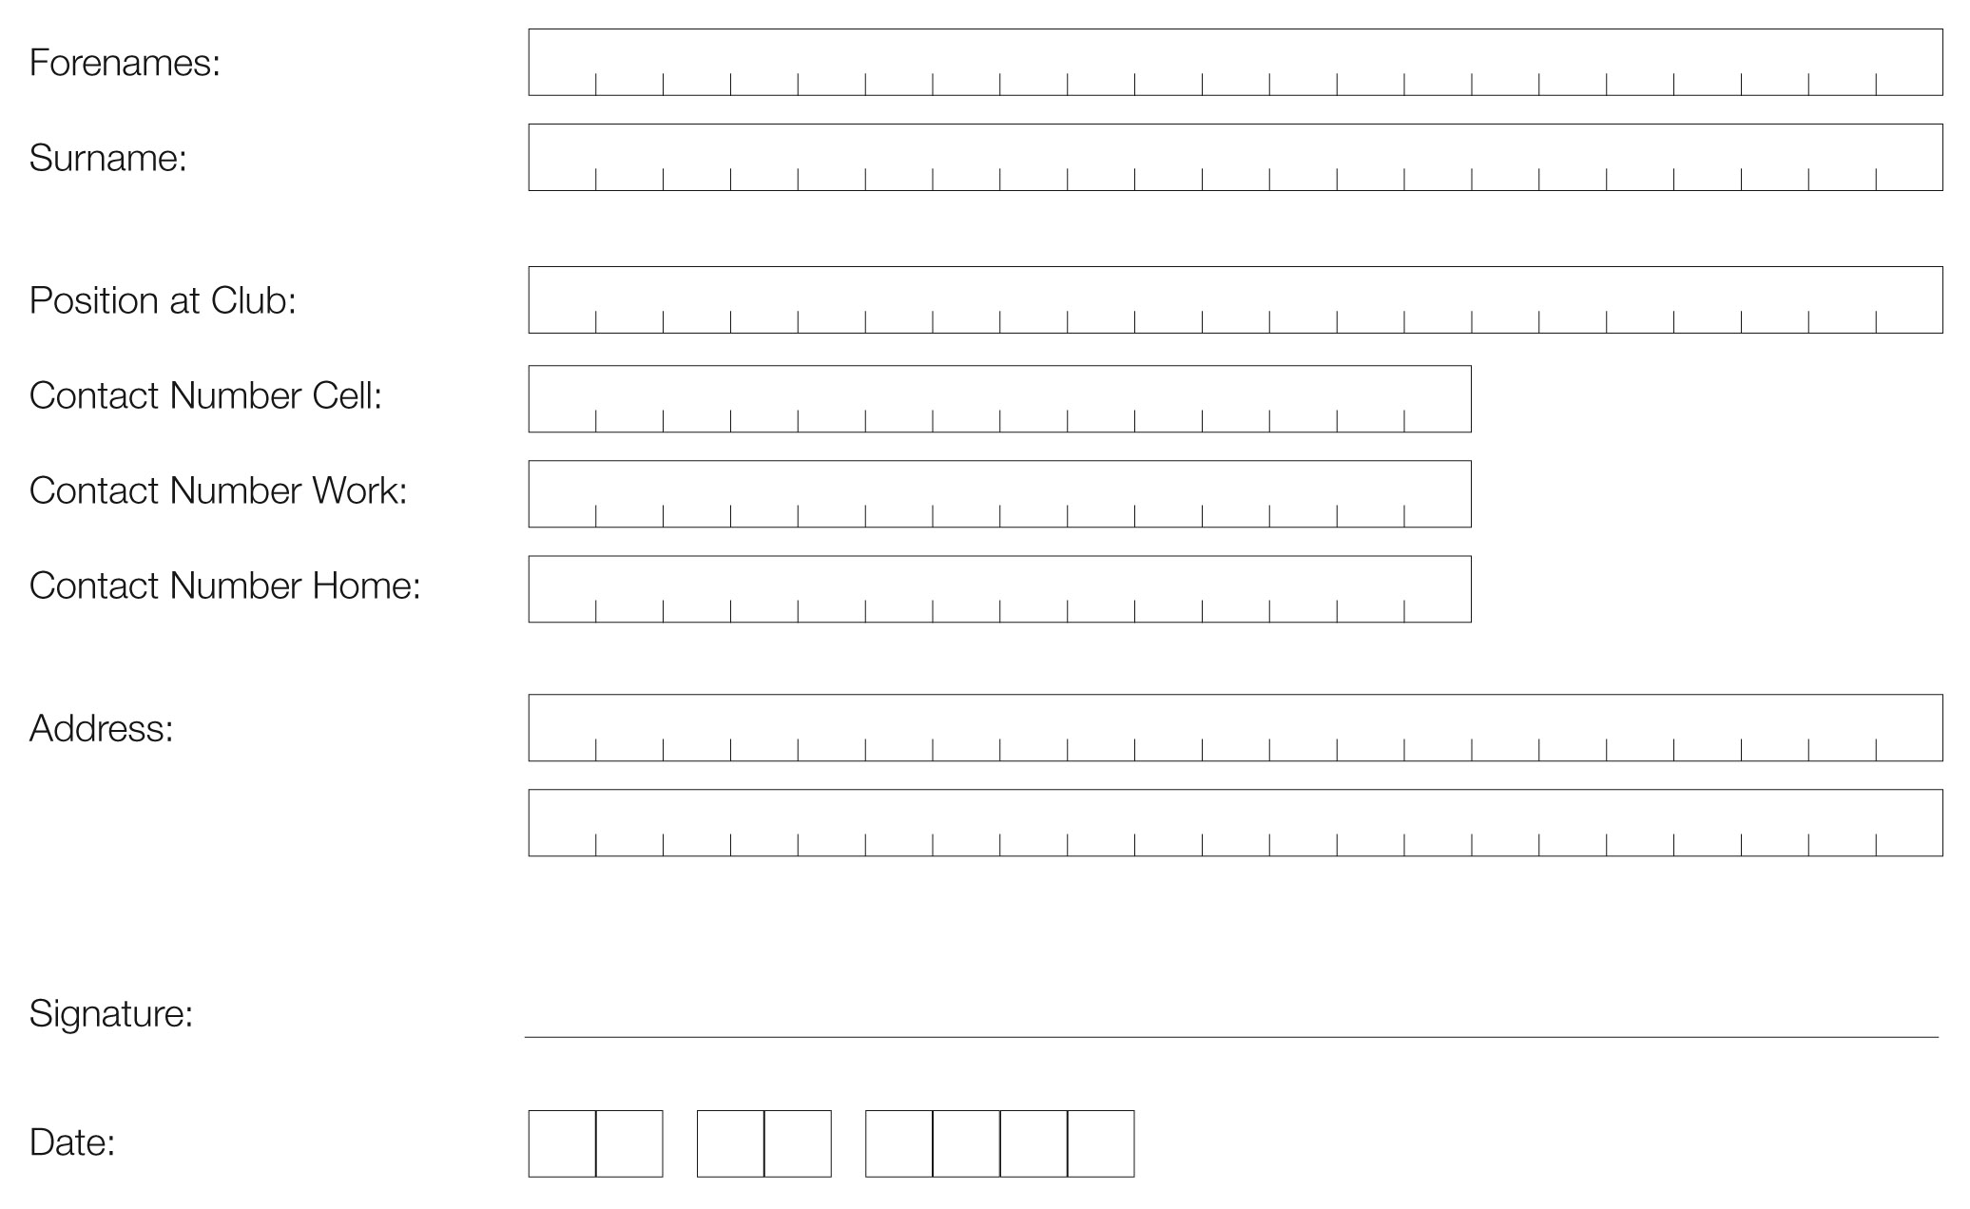
4. club contact (Print Clearly)

5. PROVINCIAL UNION Boksmart Coordinator
CONTACT DETAILS:

Boland: Linston Manuels | 0822293301 | 0218732317 | linston@bolandrugby.com
Border: David Dobela | 0767715781 | david@brurugby.co.za
Blue Bulls: Hennie Janse van Vuuren | 0792216370 | 0124200709 | henniev@bluebull.co.za
SWD Eagles: Martin de Vos | 0734442551 | 0448730137 | martin@swdeagles.co.za
Eastern Province: Mazwi Dingana | 0670994112 | 0414088922 | mazwi.epru@gmail.com
Free State: Selvyn Colby | 0845834487 | 0514071749 | scolby@fsrugby.co.za
Griquas: Kat Swanepoel | 0828223770 | 0538328773 | Refs@gwrugby.co.za
Griffons: Steps (Stefan) Pretorius | 0728310998 | 0573526482 | steps@griffonsnfs.co.za
Leopards: Henry Stewart | 0845876369 | 0182975304 | stewart@leopardsrugby.co.za
Lions: Timmy Goodwin | 0828508707 | 0114022960 | timmy@glru.co.za
Pumas: Oubaas Coetzer | 0827699624 | 0136120534 | oubaas@pumas.co.za
Sharks: Archie Sehlako | 0844317562 | 0313088426 | archie@kzn-rugbyunion.co.za
Valke: Alfred Ross | 0824573278 | 0169762112 | aross@icon.co.za
Western Province: Samuel Mahlatsi | 0798843600 | 0216594502 | smahlatsi@wprugby.co.za

